**Git Tutorial**

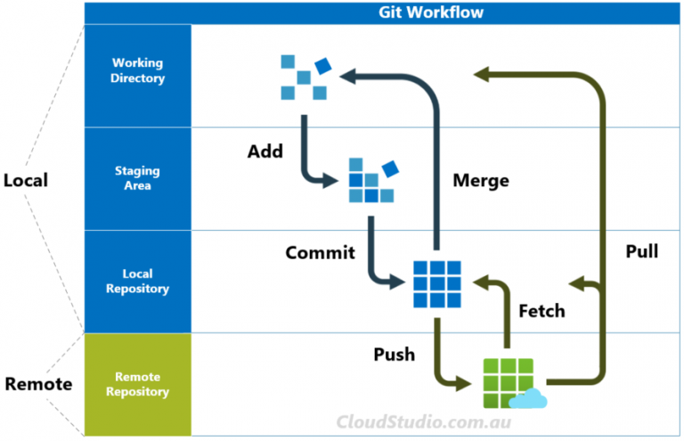

## **Key Commands**

| **Commands** | **Description and Exmaples** |
| --- | --- |
| **git add** | **Stage changes for next commit**  ***git add .***  ***git add file_name***  ***git add c:\local_repo_name\repo_folder_name/sub_folder_name*** |
| **git commit** | **Commit the staged snapshot to the local repository**  ***git commit -m "commit message"*** |
| **git push** | **Upload local repository content to a remote repository**  ***git push origin master***  ***git push -u origin local_branch_name*** |
| **git fetch** | **Download content from remote repository, but doesn’t force the merge**  ***git fetch origin master*** |
| **git merge** | **Join two branches together**  ***git merge local_branch_name***  ***git merge local_branch_1 local_branch_2*** |
| **git pull** | **Combo of git fetch and git merge**  ***git pull***  ***git pull origin remote_branch_name*** |

**For detailed Git reference, see** [**https://git-scm.com/docs**](https://git-scm.com/docs)

## **Additional Commands**

**To make it easier for searching, we’ve put the commands below in the alphabetical order.**

| **Commands** | **Description and Examples** |
| --- | --- |
| **git blame** | **Review a file’s modification history**  ***git blame file_name***  ***git blame -L 1,10 file_name***  **It’s often used together with *git log* to find out what, how and why a change was made to a file** |
| **git branch** | **manage branches of a repository, e.g. create, list, rename and delete**  ***git branch new_branch_name***  ***git branch***  ***git branch -a***  ***git branch -m renamed_branch_name***  ***git branch -d existing_branch_name*** |
| **git checkout** | **Switch to another branch in the working directory**  ***git checkout local_branch_name***  ***git checkout -b new_branch_name*** |
| **git clean** | **Remove the untracked files**  ***git clean -n***  ***git clean -f***  ***git clean -dn***  ***git clean -df*** |
| **git clone** | **Clone a remote repository on to a local repository**  ***git clone https://github.com/aws/aws-toolkit-eclipse.git*** |
| **git config** | **Customise the git environment**  ***git config --list --show-origin***  ***git config --global user.name "Richard"***  ***git config user.name*** |
| **git diff** | **Inspect changes in a repository**  ***git diff***  ***git diff file_name***  ***git diff commit_id_1 commit_id_2***  ***git diff branch_name_1 branch_name_2*** |
| **git init** | **Create an empty Git repository in a specified directory**  ***git init c:\local_repo_name\repo_folder_name*** |
| **git log** | **View the commit history of a branch**  ***git log***  ***git log -p -3*** |
| **git rebase** | **Move one branch to the tip of another branch**  ***git rebase base_branch_name***  **\*do not rebase any shared branches** |
| **git reflog** | **View the HEAD change history of all local branches**  ***git reflog***  ***git reflog --all -3*** |
| **git remote** | **Manage remote repositories’ information stored locally**  ***git remote -v***  ***git remote repository_name repository_url***  ***git remote rm repository_name*** |
| **git reset** | **Move both current HEAD pointer and branch ref pointer**  ***git reset --soft commit_id***  ***git reset --mixed commit_id***  ***git reset --hard commit_id***  ***git reset commit_id file_name*** |
| **git revert** | **Undo changes to a commit history**  ***git revert HEAD***  ***git revert commit_id***  ***git revert -n HEAD*** |
| **git rm** | **Remove tracked files from the staging area and (but not or) working directory**  ***git rm file_name_1 file_name_2***  ***git rm --cached file_name_1***  ***git rm -r folder_name*** |
| **git stash** | **Save and hide committed and uncommitted changes**  ***git stash save "stash_message"***  ***git stash -u***  ***git stash -a***  ***git stash -p***  ***git stash list***  ***git stash show***  ***git stash pop***  ***git clean -n -d -x*** |
| **git status** | **View the state of working directory and staging area**  ***git status***  ***git status -s*** |
| **git tag** | **Snapshot specific points in a repository history**  ***git tag***  ***git tag -a tag_name -m "tag message"***  ***git tag -a tag_name commit_id*** |

**For detailed Git reference, see** [**https://git-scm.com/docs**](https://git-scm.com/docs)

## **Advanced Tips**

| **Case** | **Example** |
| --- | --- |
| **Set up git alias** | ***git config --global alias.lol "log --oneline --graph --decorate"***  ***git config --global alias.ch "checkout"***  ***git config --global alias.br "branch"***  ***git config --global alias.co "commit"***  ***git config --global alias.st "status"*** |
| **Config levels** | ***--local* apply configuration at the repository level (<repository folder/.git/config>)**  ***--global* apply configuration at the user level (C:\Users\<user name>\.gitconfig)**  ***--system* apply configuration for all users across an entire machine (C:\ProgramData\Git\config)** |
| **Customise git log format** | ***git log --pretty=format:"%cn committed %h on %cd"***  ***git log --oneline --graph --decorate*** |
| **Filter git log output** | ***git log --after="yyyy-mm-dd" --before="yyyy-mm-dd"***  ***git log --author="author1\|author2"***  ***git log --grep="commit_message_key_word"***  ***git log -S"file_content_key_word"***  ***git log branch_name_1 branch_name_2*** |
| **Some plumbing commands** | ***git cat-file -p HEAD***  ***git ls-tree -r HEAD***  ***git ls-files -s*** |
| **Wildcard git rm** | ***git rm folder_name/\*.yml***  ***git rm *.tags*** |
| **Undo git rm** | ***git reset HEAD***  ***git checkout .*** |